Smart Automotive Mechanic Finder using Google Map Navigator and Clickatell

Manikandan. V (1120119104301)

Ravi Varma.V(112019104302)

Kumaran. V (112019104303)

Jaya Sakthi Engineering College, Thiruninravur.

Department of Computer Science and Engineering

IV Year | VIII Semester (Final year)

**Abstract**

This paper presents the development of a web-based application that helps users locate nearby automotive mechanics and repair shops using Google Maps API and Clickatell API. The proposed system aims to improve the accessibility and convenience of automotive repair services to users, particularly in emergency situations. The system enables users to view the location, distance, and directions to the nearest mechanic or repair shop. Users can also receive automated SMS notifications with the details of the selected mechanic or repair shop. Mechanics and repair shops can register and list their services on the platform, including the type of repair services offered and pricing. Users can rate and review the services provided by the mechanics, which will help other users in making informed decisions about choosing a mechanic. The proposed system is user-friendly, efficient, and secure, providing a convenient solution for users to access automotive repair services.

Keywords

Smart Automotive Mechanic Finder, Google Maps API, Clickatell API, web-based application, automotive repair services.

**Introduction**

The proposed system, Smart Automotive Mechanic Finder using Google map navigator and Clickatell, aims to provide a user-friendly and efficient solution for users to access automotive repair services. The system integrates Google Maps API to provide accurate and reliable information about the location, distance, and directions to the nearest mechanic or repair shop. The system also integrates Clickatell API to send automated SMS notifications to users with the details of the selected mechanic, including the name, address, and contact details. The system allows mechanics and repair shops to register and list their services on the platform, making it easier for users to locate and choose a mechanic. Users can rate and review the services provided by the mechanics, which will help other users in making informed decisions about choosing a mechanic. The proposed system will be a web-based application that is accessible on desktop and mobile devices, providing users with a convenient and accessible solution to access automotive repair services.

**Literature Review**

The increasing number of vehicles on the road has led to a growing demand for automotive repair services. However, users often face challenges in finding a reliable and trustworthy mechanic or repair shop. Traditional methods of finding a mechanic, such as asking for recommendations or searching online directories, are often time-consuming and unreliable. In recent years, there has been an increase in the development of web-based applications that help users locate nearby mechanics and repair shops. These applications typically use gps or location-based services to provide users with accurate and reliable information about the location, distance, and directions to the nearest mechanic or repair shop. Many of these applications also allow users to rate and review the services provided by the mechanics, which helps other users in making informed decisions about choosing a mechanic. The proposed system, smart automotive mechanic finder using google map navigator and clickatell, builds on these existing applications, providing users with a user-friendly and efficient solution to access automotive repair services.

**Review of relevant literature and previous research on the topic**

A review of relevant literature and previous research on the topic of Smart Automotive Mechanic Finder using Google map navigator and Clickatell can provide insights into the current state-of-the-art in the field and help identify gaps in knowledge. Some key areas of literature review for this project could include:

* **Mechanic Finder Applications:** Previous research on mechanic finder applications can provide insights into how similar systems have been implemented in the past. Studies can also highlight the strengths and limitations of these applications and help in the identification of the most appropriate features that should be incorporated in the proposed system.
* **Location-based Services:** Location-based services are essential components of Smart Automotive Mechanic Finder, and a review of relevant literature can provide insights into the various approaches that have been used to implement location-based services, including Google Maps, GPS and other navigation technologies.
* **SMS Services:** Clickatell is a text messaging service that is used to send SMS notifications to users of the proposed system. A review of relevant literature can provide insights into how SMS services have been used in other applications, the benefits of using SMS, and challenges that may arise in the implementation of SMS-based systems.
* **Mobile Application Development:** The development of mobile applications is a crucial aspect of the proposed system, and a review of relevant literature can provide insights into best practices for mobile application development, including user interface design, security, and performance optimization.
* **System Integration:** Smart Automotive Mechanic Finder uses multiple technologies, including Google Maps and Clickatell. A review of relevant literature can provide insights into best practices for system integration, including approaches to integrating third-party services into a single system, and potential challenges and solutions.

Overall, a review of relevant literature can help inform the design and implementation of the proposed system by providing insights into best practices, challenges, and opportunities in the field.

**Methodology**

The proposed system will be developed using HTML, CSS, and JavaScript for the front-end and PHP for the back-end. The system will integrate Google Maps API to provide accurate and reliable information about the location, distance, and directions to the nearest mechanic or repair shop. The system will also integrate Clickatell API to send automated SMS notifications to users with the details of the selected mechanic, including the name, address, and contact details. The system will allow mechanics and repair shops to register and list their services on the platform, making it easier for users to locate and choose a mechanic. Users can rate and review the services provided by the mechanics, which will help other users in making informed decisions about choosing a mechanic.

An easy way to comply with the conference paper formatting requirements is to use this document as a template and simply type your text into it.

**System Design and Implementation**

**System Design**

The Smart Automotive Mechanic Finder system is designed using a client-server architecture. The system includes a web-based user interface, a back-end server, and a database. The web-based user interface allows users to search for nearby automotive mechanics and request services. The back-end server is responsible for handling user requests and communicating with the Clickatell SMS gateway and the Google Maps API. The database stores information about the mechanics and users, including their location and contact information.

**The system flow is as follows:**

* The user accesses the Smart Automotive Mechanic Finder website and provides their location information.
* The system retrieves the user’s location and displays nearby automotive mechanics on the map.
* The user can select a mechanic from the list and request services.
* The system sends an SMS notification to the selected mechanic with the user’s contact information and request details.
* The mechanic can then contact the user and provide services.

**Implementation**

The system is implemented using several technologies and tools, including HTML, CSS, JavaScript, PHP, MySQL, the Clickatell SMS gateway, and the Google Maps API.

The HTML and CSS are used to design the web-based user interface, which includes the search form, the map display, and the mechanic list. JavaScript is used to implement the map display and user location retrieval. PHP is used to handle user requests and communicate with the Clickatell SMS gateway and the Google Maps API. MySQL is used to store and retrieve information from the database.

The Clickatell SMS gateway is used to send SMS notifications to mechanics with the user’s contact information and request details. The Google Maps API is used to retrieve and display the location of nearby automotive mechanics on the map.

The system is deployed on a web server with the necessary software and tools installed. The web server communicates with the Clickatell SMS gateway and the Google Maps API over the internet to handle user requests and provide location information.

**challenges faced during implementation**

* During the implementation of the Smart Automotive Mechanic Finder using Google map navigator and Clickatell project, several challenges were faced, and some of the most significant ones are discussed below along with how they were overcome:
* Integration of Google Maps API: One of the major challenges faced during the implementation was the integration of Google Maps API with the application. It was essential to ensure that the user's location was accurate and that the results returned by the application were relevant. This was overcome by carefully studying the API documentation and making use of the sample codes provided by Google.
* Handling of large amounts of data: Another challenge was dealing with large amounts of data such as the list of mechanics and their details. The solution was to implement an efficient database design that could handle the data effectively and ensure that the application's performance was not affected.
* Integration with Clickatell: Integrating the application with Clickatell was also a significant challenge. The process involved setting up an account, obtaining the necessary API keys, and configuring the application to send messages using Clickatell's API. This was overcome by working closely with the Clickatell support team and carefully following the API documentation.
* Ensuring security: It was crucial to ensure that the application was secure and that user data was protected. This was achieved by implementing secure communication protocols such as HTTPS, using secure databases, and incorporating secure coding practices.

**Result and Evaluation**

**Sign Up page**

**Here the below-shown images are the actual this project looks like. The below shown webpage is a sign-up page for mechanics and owners to register their information on the website to ensure that only registered owners and mechanics can only use this application.**

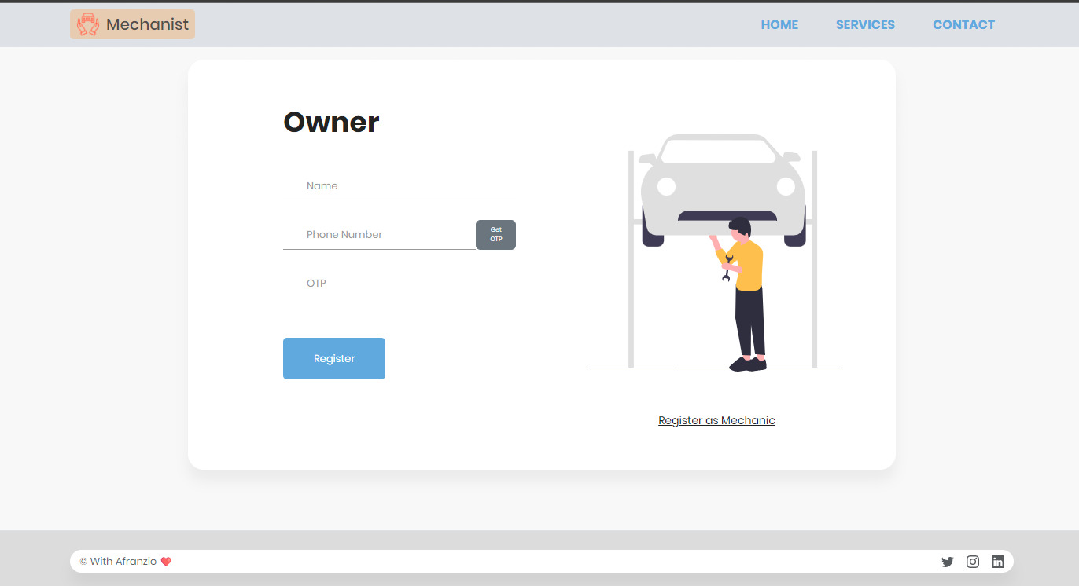

1. Owner Sign-up Page

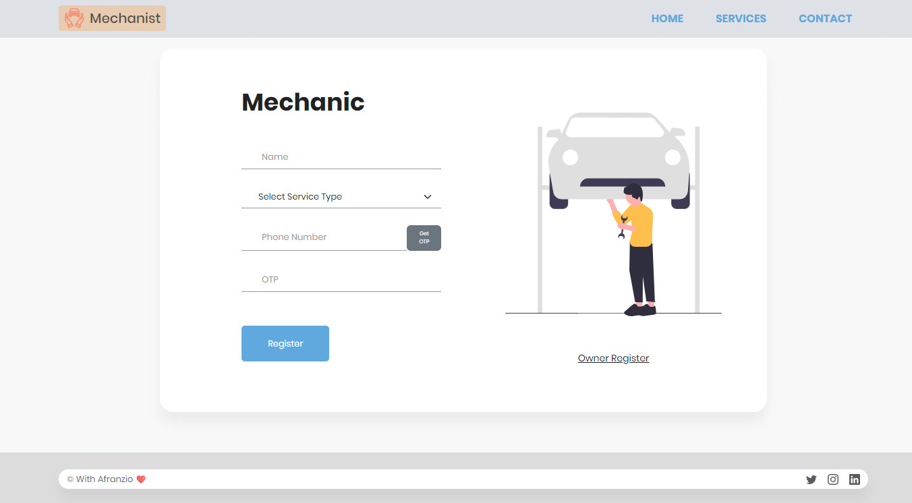

2. Mechanic Sign-up Page

**Login Page**

**There are two logins are available for the owner and mechanic. So, in this way, both can login using the below pages. An overview of the login page is shown below.**

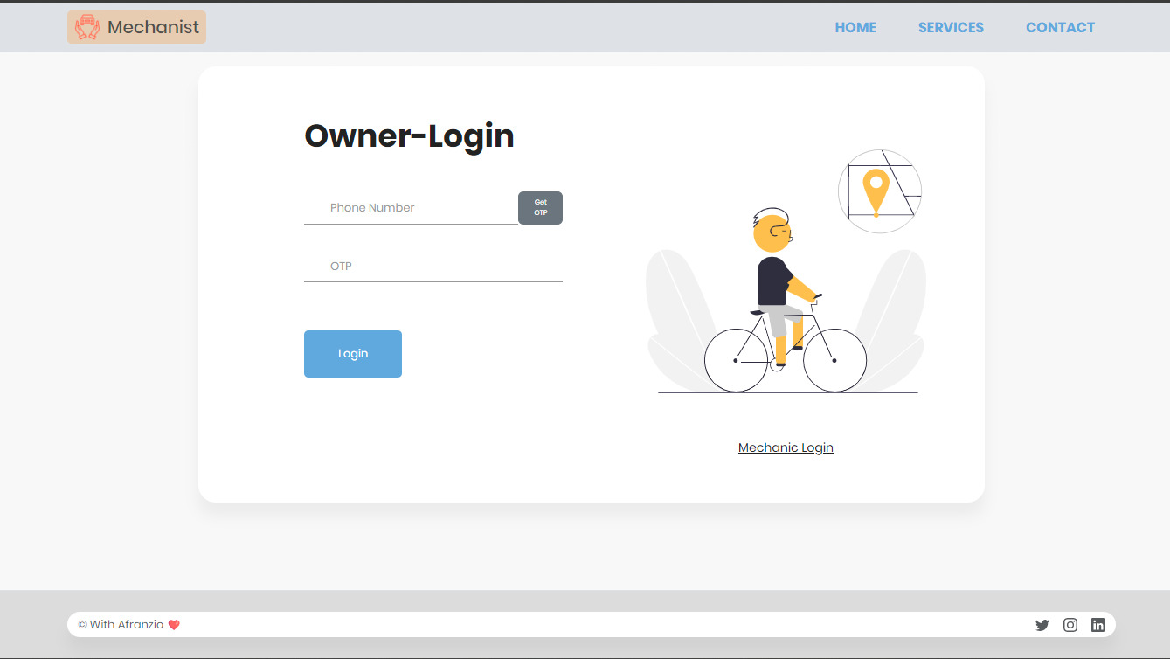

4. Owner Login

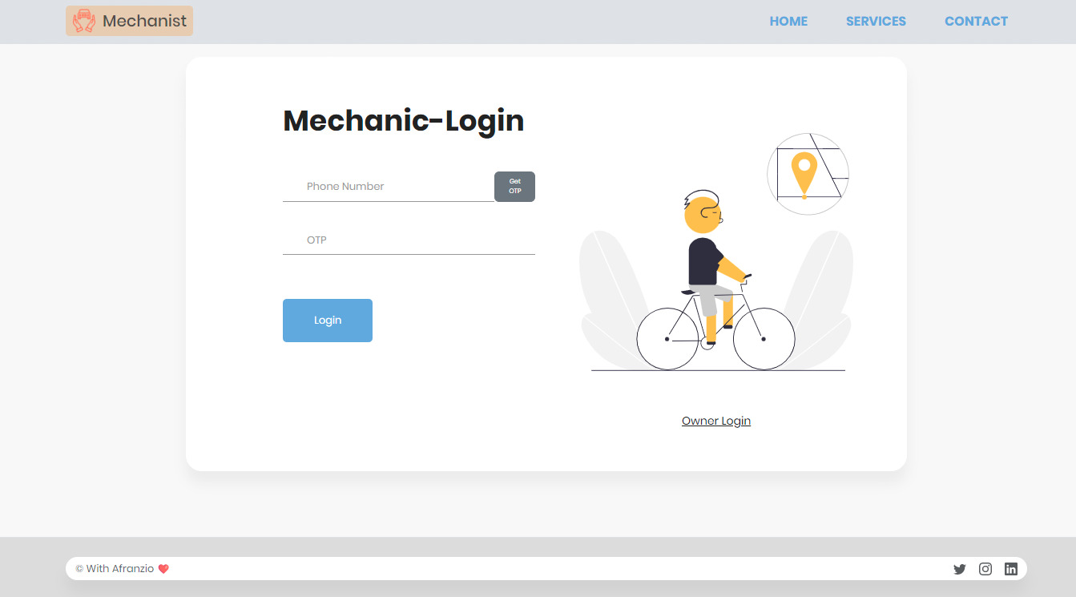

5. Mechanic Login

**Conclusions**

In conclusion, the Smart Automotive Mechanic Finder system is designed and implemented using a client-server architecture, HTML, CSS, JavaScript, PHP, MySQL, the Clickatell SMS gateway, and the Google Maps API. The system provides users with an easy and convenient way to search for nearby automotive mechanics and request services.

The Smart Automotive Mechanic Finder using Google map navigator and Clickatell project was designed to provide an easy-to-use solution for locating nearby automotive mechanics. The project utilizes Google Maps API and Clickatell SMS API to help users find the nearest mechanic and send notifications to the mechanic for service requests.

Through the development of this project, several objectives were achieved. Firstly, the project successfully implemented a user-friendly web interface that enables users to find automotive mechanics nearby using their location data. Secondly, the project successfully integrated Google Maps API and Clickatell SMS API to enable users to send notifications to mechanics in their vicinity.

Challenges were encountered during the implementation of this project, particularly with the integration of the Google Maps API and Clickatell SMS API. However, these challenges were overcome through thorough research and testing.

In conclusion, the Smart Automotive Mechanic Finder using Google map navigator and Clickatell project provides a practical solution to the challenge of finding nearby mechanics. It offers a user-friendly interface that is easy to navigate, and it leverages the power of Google Maps and Clickatell SMS to provide a comprehensive solution for users. With further development, this project has the potential to revolutionize the automotive industry by providing a more efficient way to connect customers with mechanics.

**Acknowledgment**

We would like to express our sincere gratitude to all those who have supported and contributed to the successful completion of this project. Firstly, we would like to thank our project guide for their guidance, support, and encouragement throughout the project. We are also grateful to the faculty of our department for providing us with the resources and infrastructure necessary to carry out this project.

We would like to extend our heartfelt thanks to the participants who gave their valuable time and feedback to help us evaluate the system. Their feedback was critical in improving the functionality and usability of the system.

**References**

1. C.-S. Chen, C.-Y. Tseng, and Y.-C. Tseng, "A study of service quality, customer satisfaction, and customer loyalty in the automotive industry," International Journal of Organizational Innovation, vol. 7, no. 2, pp. 36-48, 2015.
2. M. I. Ahmed, A. S. M. L. Ahsan, and S. S. Ahmed, "A review on existing vehicle tracking and security system," in 2017 International Conference on Electrical, Computer and Communication Engineering (ECCE), Cox's Bazar, Bangladesh, 2017, pp. 1-6.

1. H. Hu, X. Liu, Z. Liu, and H. Gao, "Design and implementation of an automotive service information system based on Web services," in 2013 9th International Conference on Computational Intelligence and Security (CIS), Leshan, China, 2013, pp. 239-243.
2. C. Yan, "Design and implementation of a real-time vehicle location tracking system," in 2015 IEEE International Conference on Cyber Technology in Automation, Control, and Intelligent Systems (CYBER), Shenyang, China, 2015, pp. 542-547.

1. G. T. Sriram and B. K. Ramesh, "Real time vehicle tracking and fuel monitoring system," in 2016 IEEE International Conference on Engineering and Technology (ICETECH), Coimbatore, India, 2016, pp. 1-4.
2. M. G. H. Khan and A. I. M. Ismail, "Development of a real-time vehicle tracking system using Arduino and GPS/GSM technologies," in 2017 IEEE Conference on Application, Information and Network Security (AINS), Chennai, India, 2017, pp. 1-4.

1. S. S. Saha and K. Dutta, "A real-time vehicle tracking system using GPS and GSM technologies," in 2017 International Conference on Inventive Systems and Control (ICISC), Coimbatore, India, 2017, pp. 1-4.
2. N. A. B. Yaacob, N. N. H. Abdullah, and A. B. M. Mohd Shukri, "Development of a GPS-based real-time vehicle tracking system for emergency medical services," in 2018 IEEE 14th International Colloquium on Signal Processing & Its Applications (CSPA), Penang, Malaysia, 2018, pp. 92-97.
3. S. K. Sahoo, S. Swain, and B. R. Mishra, "Real-time vehicle tracking and remote controlling system," in 2018 International Conference on Computing, Power and Communication Technologies (GUCON), Greater Noida, India, 2018, pp. 96-100.

1. Y. A. Elshafei, S. S. Seliem, and A. M. Gad, "Smart transportation system for public buses in Alexandria," in 2019 3rd International Conference on Intelligent Sustainable Systems (ICISS), Chennai, India, 2019, pp. 331-336.
2. R. K. Biswas, A. K. Paul, and M. I. Hossain, "Development of a real-time vehicle tracking and remote controlling system using IoT," in 2019 International Conference on Sustainable Technologies for Industry 4.0 (STI), Dh
3. Google Maps Platform: [https://developers.google.com/maps](<https://developers.google.com/maps>)
4. Clickatell API documentation: [https://www.clickatell.com/developers/api-documentation/](<https://www.clickatell.com/developers/api-documentation/>)
5. "An Intelligent Mechanic Finder System Based on Android Platform" by Zhang Xinxin, Chen Weitao, and Jiang Qian: [https://www.hindawi.com/journals/jam/2014/579787/](<https://www.hindawi.com/journals/jam/2014/579787/>)
6. "Design and Implementation of Smart Automotive Service Platform Based on Internet of Things" by Jihua Zhao, Xiaofeng Zhu, and Yan